Cape Hatteras combined case study outline

Providers: Duke University and Brandon Southall Associates

Priority Species: Cuvier’s beaked whale, Short-finned pilot whale

Project years (with data on priority species): 2009-Onogoing

Introduction

Originally the Baseline Monitoring Project, the Occurrence and Ecology Project and the Atlantic BRS Project represented three separate case studies for exploration under MSM4PCoD. However during the data collation process, it became apparent that data had been collected for the Cape Hatteras region during all three projects, and the projects in reality are extensions of one another, each with a slightly different set of objectives. This presents the opportunity to combine project information, extending the temporal data range and increasing the data streams available for analysis to achieve MSM4PCOD objectives.

Project Summaries

**Baseline Monitoring Project (2009-2017)**: The project was designed as a multi-institutional monitoring project intended to provide information on the species composition, population identity, density, and baseline behaviour of marine mammals present at the navy range complexes along the Atlantic coast. Multi datastreams were collected during this long-term project.

**Occurrence and Ecology (2013-2016):** In 2013, focus was placed on deep diving cetaceans around Cape Hatteras, with tags deployed to better understand the distribution and ecology of these species. In addition to tag deployments, photo-id and biopsy sampling were conducted to increase knowledge of population structure, genetics and reproductive hormones.

**Atlantic BRS (2017-Ongoing):** This project was designed to measure the behavioural response of deep-diving odontocetes to controlled exposure experiments (CEEs) of mid-frequency active sonar (MFAS).

Data availability

* The schematic below indicates the sampling periods for the three Atlantic region projects that have been selected for further analysis within the MSM4PCoD project.
* The included data is almost entirely from short-finned pilot whale and Cuvier’s beaked whale.
* As we can see, the baseline monitoring surveys focused on PAM and boat-based data collection, with aerial surveys later.
* In contrast, the Occurrence and Ecology project focused on behaviour of deep divers, where sightings, capture-recapture, and telemetry were the primary focus.
* The annual reports from the Atlantic BRS project mostly disclosed information about telemetry studies, with some mention of capture-recapture and biopsy, more information is therefore required to better understand the availability of these data streams for this project.
* At first glance, Figure 1 demonstrates that there is potential to combine long term datasets with additional information sourced from capture recapture and perhaps other data sources too.

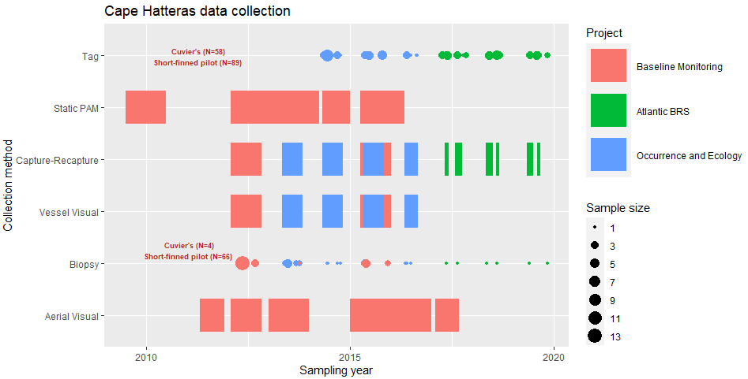

Figure 1: A graphical representation of the data available for the Cape Hatteras region over the three projects outlined above. The colour represents which project the data was collected under, and sample size refers to the number of tags/biopsy samples collected on a given date. The ‘N=’ represents the total number of tags or samples for Cuvier’s beaked whale and short-finned pilot whale, totalled over the three projects. See Table 1 below for further details.

N.B. The latest report for the Atlantic BRS mentions a collaborative proposal to analyse vital rates of Cuvier’s beaked whales from multiple populations, looking at photo-ID information such as pigmentation and scarring density to identify age and sex metrics (Waples and Read 2021).

Relevance to MSM4PCoD

* The combined photo-id data from these projects could potentially provide demographic information for an integrated population model (IPM) for Cuvier’s beaked whale and/or short-finned pilot whale
* Incorporating demographic information such as juvenile fraction within a population model might facilitate the detection of change within a population earlier than estimates of population size alone (Holmes and York 2003).
* This information could be derived from photo-id data, or potentially from biopsy analysis, similar information has been obtained from Cuvier’s beaked whales in the SOAR region in the pacific (Curtis et al. 2020)
* A complementary exploration could include the involvement of telemetry data. This has been used in terrestrial species to improve precision of abundance estimates (Murphy et al. 2019), and could be considered in this project.
* Validating the IPM method could steer future research efforts towards integrated data collection for more precise abundance estimates of marine mammals, and the large-scale surveys conducted by the Navy provides an opportunity to apply this model to real data
* This method was recently simulated for a large whale population and demonstrated that incorporating additional demographic information can allow for the correct interpretation of a changing trend in a population (Boyd and Punt 2021).
* The use of IPMs is a developing research field, where a case study with Cook Inlet Beluga whale demonstrated the value of combining data streams to estimate population trajectories (Jacobson et al. 2020)
* Alternatively, or perhaps additionally, as there are different types of time series data (aerial, PAM, boat surveys), a spatiotemporal model could be considered that integrates these sources to create a patchwork combined analysis of species presence.

Questions for data holders

Baseline Monitoring

* Were all visual surveys based on the assumption that g (0) = 1?
* Have the photo-id datasets also been analysed for sex and age?
* Has the photo-id data been incorporated into any other analysis reports or publications? (The website links for these projects are mostly blank)
* Has the biopsy data been analysed and reported?
* Where might we find the data for the later (2016-2018) HARP surveys?

Occurrence and Ecology

* Has the photo-id data collected during this project been evaluated on an annual basis?
* Has the photo-id data collected during this project been evaluated for photo quality and distinctiveness?
* Has there been effort to age and sex animals from photographs (and also from the biopsy data)?
* We have this project listed as spanning between 2013-2017, but Foley et al 2017 contains summary statistics on matches from 2006, was this early data part of another study? (i.e the baseline surveys for the Atlantic)
* Have biopsy samples been analysed to identify pregnant individuals?
* In terms of visual surveys, is it possible to evaluate g(0) from this work given the methodology of data collection?

Atlantic BRS

* Are there detailed, annual capture-recapture data available for the Cape Haterras Cuvier’s beaked whales and short-finned pilot whales? Do they include evaluations of sex and age class?
* If photo-id data has not been evaluated for demographic information, is this a possibility with additional funding?
* What are the current sizes of the Cape Hatteras Cuvier’s beaked whale and short-finned pilot whale catalogs?
* Has the biopsy data that was collected during this project been analysed/involved in further research at this point?
* Given that this dataset reports multi-year photo-id data, are there also annual sighting data for this area with information on survey effort (distance and hours), survey design, sightings, and group size?
* Is there more information available about the vital rates proposal to ONR?

Table 1: A more detailed depiction of data available in the Cape Hatteras region by project

|  |  |  |  |  |  |  |
| --- | --- | --- | --- | --- | --- | --- |
| **Project** | **Survey method** | | | | | |
|  | **Visual (Boat-based)** | **Aerial** | **PAM** | **CRC** | **Tag** | **Biopsy** |
| **Baseline Monitoring** | Over 215 hours in the Cape Hatteras region, 1,395 km were surveyed. In early reports g(0) = 1 is mentioned. | 35,416 km were surveyed, hours not reported. Left and right sighting info available on OBIS | Primarily HARP data is reported as the number of days with detections for each species. Number of hours of data often recorded. | Catalog size and match information is reported for all reports | NA | Short-finned pilot whale (n=39) |
| **Occurrence and Ecology** | Conducted over 343.7 hours, covering 2901.5 km. Number of animals within each encounter are reported | **NA** | **NA** | Only 2013 report includes catalog size info for GM and ZC | Cuvier’s beaked whale (n=15, satellite tags). short-finned pilot whale (n=52, 8 DTAG, 44 satellite tags), Sperm whale (n=1) | Cuvier’s beaked whale (n=4), short-finned pilot whale (n=27), and sperm whale (n=2). Analysis not reported |
| **Atlantic BRS** | Sightings not reported but presumably occurred prior to CEEs | **NA** | **NA** | The annual reports for the Atlantic BRS do not include photo-ID analysis, however two summary reports are available that present re-sightings of Cuvier’s beaked whales and short-finned pilot whales | 44 tags on Cuvier’s beaked whale (43 satellite tags, 1 DTAG), 45 tags on short-finned pilot whales (37 satellite tags, 8 DTAGs). | Biopsy samples were taken for Cuvier’s beaked whales and short-finned pilot whales but neither sample sizes nor analysis have been presented |

References

Boyd, C., and A. E. Punt. 2021. Shifting trends: Detecting changes in cetacean population dynamics in shifting habitat. PLoS ONE **16**:e0251522.

Curtis, K. A., E. A. Falcone, G. S. Schorr, J. E. Moore, D. J. Moretti, J. Barlow, and E. Keene. 2020. Abundance, survival, and annual rate of change of Cuvier's beaked whales (Ziphius cavirostris) on a Navy sonar range. Marine Mammal Science.

Holmes, E., and A. York. 2003. Using age structure to detect impacts on threatened populations: a case study with Steller sea lions. Conservation Biology **17**:1794-1806.

Jacobson, E. K., C. Boyd, T. L. McGuire, K. E. Shelden, G. K. Himes Boor, and A. E. Punt. 2020. Assessing cetacean populations using integrated population models: an example with Cook Inlet beluga whales. Ecological Applications:e02114.

Murphy, S. M., D. T. Wilckens, B. C. Augustine, M. A. Peyton, and G. C. Harper. 2019. Improving estimation of puma (Puma concolor) population density: clustered camera-trapping, telemetry data, and generalized spatial mark-resight models. Scientific Reports **9**:4590.

Waples, D. M., and A. Read. 2021. Photo-Identification Analyses in the Cape Hatteras Study Area: 2020 Annual Progress Report.